Trigonometric Identities

Math 109
NOTE: For the chapter six exam, you will be required to know the trigonometric identities with the symbol ▪ next to it. I also recommend that you memorize the identities with the symbol ▫ next to them.

Definitions (Section 6.1)
▪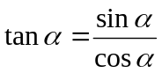 | ▪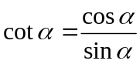 | ▪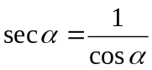 | ▪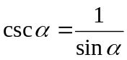

Reciprocal Identities (Section 6.1)
▪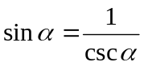 | ▪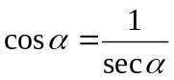 | ▪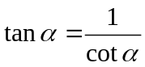
▪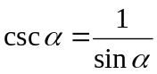 | ▪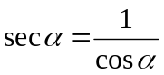 | ▪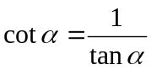

Pythagorean Identities (Section 6.1)
▪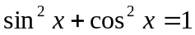 | ▪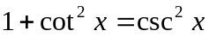 | ▪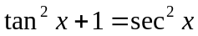

Even/Odd Identities (Section 6.1)
▪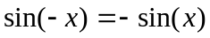 | ▪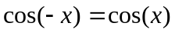 | 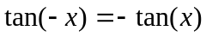
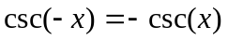 | 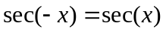 | 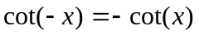

Sum and Difference Identities (Section 6.3)
▫ | ▫
▫ | ▫
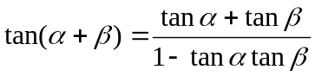 | 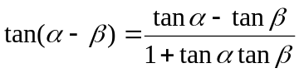

Co-Function Identities (Section 6.3)
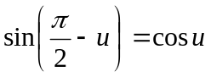 | 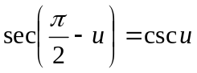 | 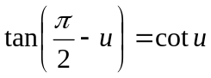
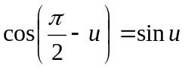 | 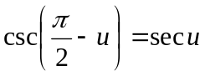 | 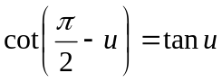

Double-Angle Identities (Section 6.4)
▪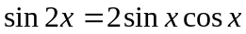 | ▪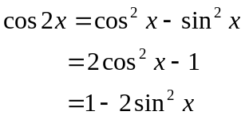 | 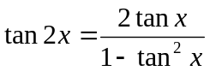

Half-angle Identities (Section 6.4)
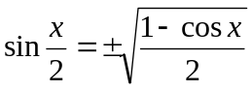 | 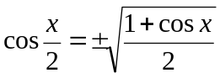 | 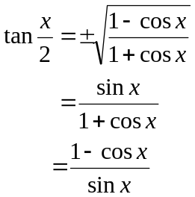

Product-to-Sum Identities (Section 6.5)
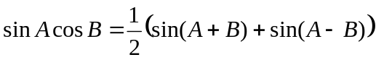 | 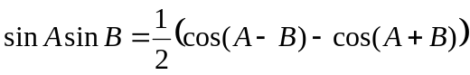
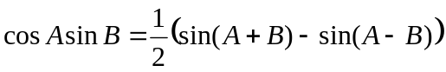 | 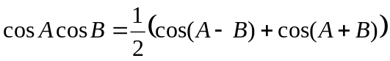

Sum-To-Product Identities (Section 6.5)
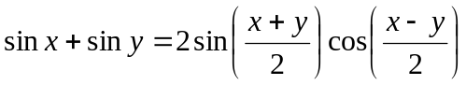 | 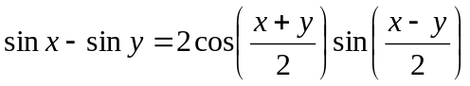
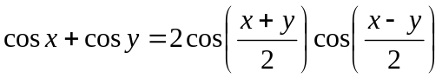 | 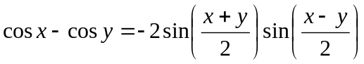

Power-Reducing Identities (Not in Textbook)
▫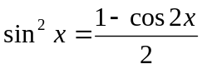 | ▫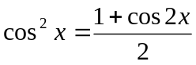 | 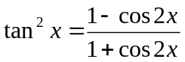

Strategies for verifying identities:
- Work on one side of the equation (usually the more complicated one) so that it looks like the other side. There are some exceptions to this rule.
- Rewrite expressions into terms of sines and cosines.
- To work with rational expressions try multiplying the numerator and denominator by the conjugate of the numerator or denominator.
- If there is a rational expression with the numerator as a sum or difference, split the expression into multiple fractions.
- If there are multiple rational expressions, then find a common denominator and combine the fractions.
- Remember to try factoring or multiplying out expressions.
- Try multiplying by a form of 1.
- Do something—even if it is wrong.

